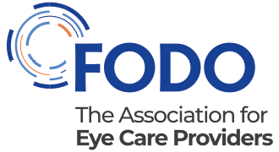

Standard precautions at a glance

You should have control measures in place to prevent or minimise the spread of Covid-19 in the workplace. All employees, contractors and other visitors should comply with these measures. You can support this by using this at-a-glance resource to train your team:

- Seven steps - training and compliance
- Training log
- Standard precautions poster

Seven steps – training and compliance

1. Promote and support compliance with official self-isolation advice
Make sure your team understands the importance of compliance with self-isolation advice. You can do this by:

- Asking all staff to complete a self-assessment each day before leaving for work
- Ensuring patients are assessed remotely before they attend a face-to-face appointment
- Displaying College of Optometrists posters to reduce the risk of a suspect or confirmed Covid-19 case entering the practice.
2. Ensure your team understands the importance of social distancing while at work
In addition to floor marking and other system controls to aid social distancing, make sure all employees know that social distancing between colleagues is also essential to help slow the spread of coronavirus. This therefore includes:
- Maintaining a 2m distance while at work – e.g. keeping a space of 2m between colleagues, customers, patients, and other visitors.
3. Promote and support compliance with best-practice hand hygiene
Ensure all staff, patients and other visitors always follow best practice hand hygiene. To support this, use official posters in the practice. Also consider using video training resources to help staff learn best practice techqnues.

- Access free videos and posters from trusted sources

It is especially important to instruct and then make sure all employees wash their hands regularly for 20 seconds following best practice standards. For example:

- Immediately before every episode of direct patient care and after any activity or contact that potentially results in hands becoming contaminated, including the removal of PPE, equipment decontamination and waste handling
- On arriving and leaving the workplace
- At the beginning and end of a break
- Before and after eating or drinking
- If they cough or sneeze or blow their nose
- Before entering enclosed spaces such as vehicles
- When changing workstations or handling equipment that others have handled, if reasonably practicable.
If handwashing is not possible, then employees must use hand sanitiser using best practice techniques.
Before performing hand hygiene:
- Fingernails should be clean and short and artificial nails or nail products not worn
- Cover all cuts or abrasions with a waterproof dressing.

If wearing an apron (bare below the elbows), and it is known or possible that forearms have been exposed to respiratory secretions (for example, cough droplets) or other body fluids, hand washing should be extended to include both forearms. Wash the forearms first and then wash the hands.

4. Explain the importance of good respiratory and cough hygiene – Catch it, Bin it, Kill it

Promote good respiratory hygiene measures through:
- Using disposable, single-use tissues to cover the nose and mouth when sneezing, coughing or wiping and blowing the nose. Used tissues should be disposed of promptly in the nearest waste bin.

Share this NHS poster with all staff, and consider displaying it in the practice, to ensure compliance with good respiratoryand cough hygiene

5. Ensure all employees know to avoid touching their face – especially eyes, nose and mouth

Instruct employees about the importance of avoiding touching their eyes, hands and mouth with their hands. This is also the case if they are using PPE.

6. Provide clear cleaning and disinfecting protocols and then ensure compliance

Make sure all staff understand that cleaning of all work areas must be conducted at regular intervals using disinfectants to kill germs and stop the spread of disease and in a visible manner to instil staff and visitor confidence. Make sure all staff have access to and comply with the practice cleaning and disinfecting protocol. Ensure cleaners and staff that lead on compliance are also familiar with cleaning and disinfecting at a glance.

7. Use the correct PPE and use it correctly when within 2m

PPE is the last line of defence, so in all cases, staff should understand that they should start with other standard precautions above. For example:
- Physical distancing >2m is preferable to working within 2m and using PPE
- Hand hygiene is a must in all cases
- Triaging suspected or confirmed cases of Covid-19 to self-isolate or a specialist pathway is safer for patients and practitioners than seeing the patient in primary eye care settings with PPE
- Suspending aerosol-generating procedures (AGPs) where possible is preferable to using PPE to perform these procedures – e.g. It’s why air-puff tonometry and Alger brushes are not being used at this stage in the pandemic.

When PPE is required, it is important the correct PPE is used and it is used correctly.

Share PPE at a glance with your staff to ensure they have read College guidance, understand what PPE to use, and how to use it.

Training log

Employee training log – standard precautions

 | I have had training in and understand the importance of compliance with:
Name | Self-isolation advice | Social distancing | Hand hygiene | Respiratory hygiene | Avoiding face touching | Practice cleaning & disinfecting protocols | Using the correct PPE and using it correctly | Signed
 | ☐ | ☐ | ☐ | ☐ | ☐ | ☐ | ☐
 | ☐ | ☐ | ☐ | ☐ | ☐ | ☐ | ☐
 | ☐ | ☐ | ☐ | ☐ | ☐ | ☐ | ☐
 | ☐ | ☐ | ☐ | ☐ | ☐ | ☐ | ☐
 | ☐ | ☐ | ☐ | ☐ | ☐ | ☐ | ☐
 | ☐ | ☐ | ☐ | ☐ | ☐ | ☐ | ☐
 | ☐ | ☐ | ☐ | ☐ | ☐ | ☐ | ☐
 | ☐ | ☐ | ☐ | ☐ | ☐ | ☐ | ☐
 | ☐ | ☐ | ☐ | ☐ | ☐ | ☐ | ☐
 | ☐ | ☐ | ☐ | ☐ | ☐ | ☐ | ☐
 | ☐ | ☐ | ☐ | ☐ | ☐ | ☐ | ☐
 | ☐ | ☐ | ☐ | ☐ | ☐ | ☐ | ☐
 | ☐ | ☐ | ☐ | ☐ | ☐ | ☐ | ☐
 | ☐ | ☐ | ☐ | ☐ | ☐ | ☐ | ☐
 | ☐ | ☐ | ☐ | ☐ | ☐ | ☐ | ☐
 | ☐ | ☐ | ☐ | ☐ | ☐ | ☐ | ☐
 | ☐ | ☐ | ☐ | ☐ | ☐ | ☐ | ☐
 | ☐ | ☐ | ☐ | ☐ | ☐ | ☐ | ☐
 | ☐ | ☐ | ☐ | ☐ | ☐ | ☐ | ☐
 | ☐ | ☐ | ☐ | ☐ | ☐ | ☐ | ☐

Standard precautions poster

Help us reduce the risk of virus transmission

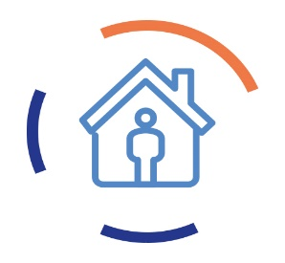 | Ensure staff, patients and other visitors self-isolate and seek medical advice in line with official guidance
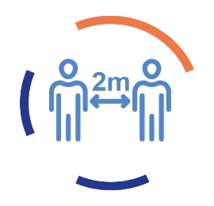 | Follow social distancing rules – stay 2m away
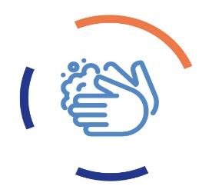 | Regularly wash your hands using best-practice guidelines. Otherwise use hand sanitiser.
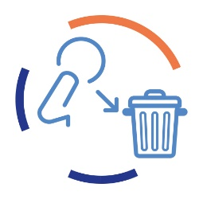 | Practise and promote good respiratory and cough hygiene – Catch it, Bin it, Kill it
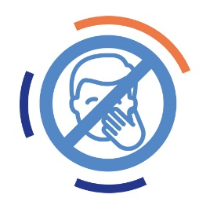 | Avoid touching your face – especially eyes, nose and mouth
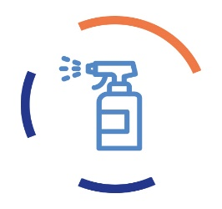 | Clean and disinfect according to the practice protocol
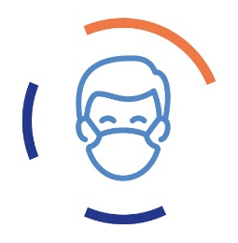 | Use the correct PPE and use it correctly when within 2m

Get more support and advice @Covid-19 resource hub

